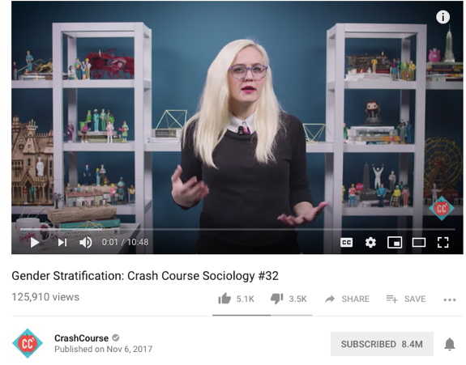
https://www.youtube.com/watch?v=Yb1_4FPtzrI

Hold your camera over the QR code and it will scan and open up as a link. If you don’t have an iPad/iphone you might need a QR scanning app, or just type in the URL (above) or words “Gender Stratification: Cras Course Sociology” into YouTube.

Remember you can pause the video, go back and look again in order to get answers and understanding.
Note: Gender and population are linked because women are the ones who carry children and give birth.
- Read glossary carefully.
- Watch the video and answer the below questions.
- When were women allowed to vote in the USA?
- When were women allowed to vote in Saudi Arabia?
- How many extra hours a week to women work in the “second shift” according to this video?
- What is the increase (difference between) in high school girls playing sport in 1970 and now in the USA?
- Why did Title IX make a difference to Sally Ride?

- What % of women make up house of representatives and senate in the USA according to this video?
- Why is it harder for women to negotiate for higher salaries in comparison to men?

- How do you feel about the topics covered in this video, what do you think about terms like girly and manly and the gendering of inanimate objects? (Complete in your book or on extra paper)

Glossary
Word | Definition
Inanimate object | A thing that is not alive such as a rock, chair, book, shampoo, coffee, t-shirt etc.
Gender | The state of being male or female, reference to socially constructed concept of male and female (society made ideas of what it is to be a man and a woman). Personal and social characteristics of a person. Someone can be female, male, or non gender where they choose not to have a gender and pronouns ze (she/he) and hir/zir (him/her) are used.
Sexes | The biological features which make us a male or female anatomy, based on their reproductive functions.
Social construct | Something society (people) has made up/invented/created based on shared understandings and assumptions of the world we live in. (Social constructs are not always good things, as society changes and is dynamic).
Gender Stratification | The unequal distribution of wealth, power and privilege (advantage /entitlement) across genders.
Disenfranchisement | Being deprived of a right or privilege, especially the right to vote
Patriarchy | A form of social organization in which men have more power and dominate other genders (most societies in history).
Matriarchy | A system or society governed or ruled by women (not very common but can be found in some African tribes like the Tuareg in Mali, however now extremist Muslims are trying to rule Mali, there is conflict and women rule doesn’t happen in extremist Muslim societies)
Sexism | Prejudice, stereotyping or discrimination typically against women on the basis of biologically allocated sex.
Hegemonic Masculinity | A practice that legitimizes (validates/supports) men’s dominant position in society and justifies the subordination (inferiority) of women. Like when men are shamed for “running like a girl” or liking pink.
Second Shift | Women come home from work to more work, cooking, laundry, childcare; but men are more likely to spend their time in leisure after work.
Emphasized Femininities | Women becoming more like the way men want them to appear i.e. weaker, clumsy, sexy etc. (where as the reality is women can be all sorts of things, sporty, strong, intelligent etc.)
Title IX (9) | 1972 USA federal law that states that no person can be excluded from participation on the basis of their sex, in any educational program, particularly sports.
Glass ceiling | The invisible barrier that stops women’s advancement to the top levels of an organisation.
Gender wage gap | The average difference between the salary of men and women who are working. Approximately white Women make 80p to every £1 that a man makes (black women 65p, Hispanic women 58p), women make less on average.
Bread winner | A person who earns money to support their family, historically this was normally the man.

