Development Indicators | Data for your country
Median Age | 32.4 years
Mothers mean age at first birth | Approx. 21 years old (no clear data)
Infant mortality | 16.9 deaths / 1000 live births
Fertility rate | 1.75 children born / women
Life expectancy | 74.3 years
Birth rate | 13.9 births / 1000 population
Death rate | 6.7 deaths / 1000 population
Adult literacy | 92%
Obesity prevalence | 22.1%
Urban population | 86.8%
Number of airports with paved runways | 698
Population without electricity | 0%
Electricity from fossil fuels | 17% (64% from hydro electric plants, 1% nuclear)
Electricity from other renewable sources | 18%





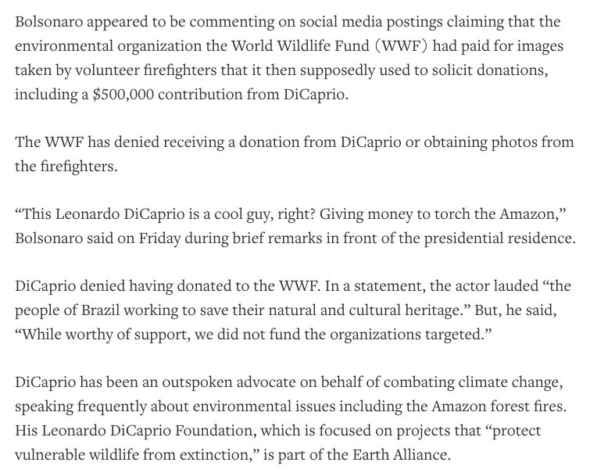





Factor | Your guess
LIDC/EDC/AC
Continent
View on Climate Change
Country 1st guess
Country 2nd guess

