Development Indicators | Data for your country
Median Age | 15.8 years
Mothers mean age at first birth | 17.9 years
Infant mortality | 71.7 deaths / 1000 live births
Fertility rate | 5.9 children born / woman
Life expectancy | 57.5 years
Birth rate | 43 births / 1000 population
Death rate | 10.5 births / 1000 population
Adult literacy | 22.3%
Obesity prevalence | 6.1%
Urban population | 23.3%
Number of airports with paved runways | 9
Population without electricity | 91%
Electricity from fossil fuels | 98%
Electricity from other renewable sources | 3%








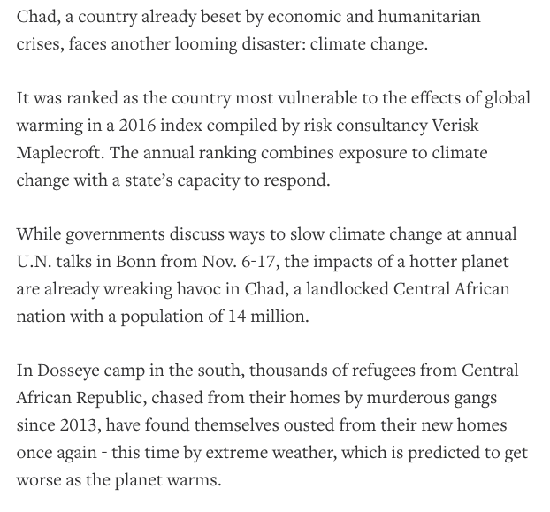

Factor | Your guess
LIDC/EDC/AC
Continent
View on Climate Change
Country 1st guess
Country 2nd guess

