Development Indicators | Data for your country
Median Age | 47.4 years
Mothers mean age at first birth | 29.4 years
Infant mortality | 3.4 deaths / 1000 live births
Fertility rate | 1.46 children born / woman
Life expectancy | 80.9 years
Birth rate | 8.6 births / 1000 population
Death rate | 11.8 deaths / 1000 population
Adult literacy | 99%
Obesity prevalence | 22.3%
Urban population | 77.4%
Number of airports with paved runways | 318
Population without electricity | 0%
Electricity from fossil fuels | 41% (5% nuclear, 2% hydro)
Electricity from other renewable sources | 52%

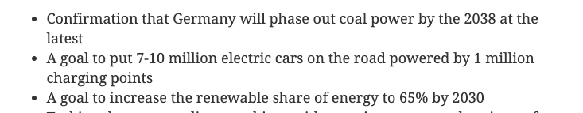











Factor | Your guess
LIDC/EDC/AC
Continent
View on Climate Change
Country 1st guess
Country 2nd guess

