Model United Nations
Climate Conference
2020

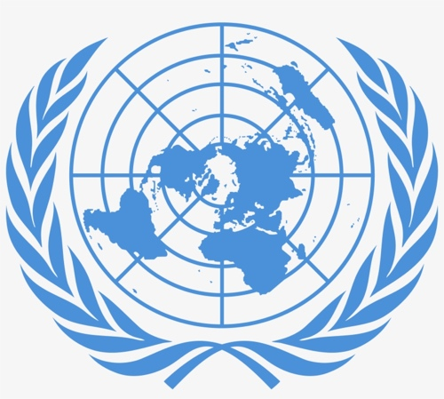

Climate Summit: A Race We Can Win

“I commit myself, and the entire United Nations, to this effort. We will support all leaders who rise to the challenge.”

Antonio Guterres, Secretary-general of the UN

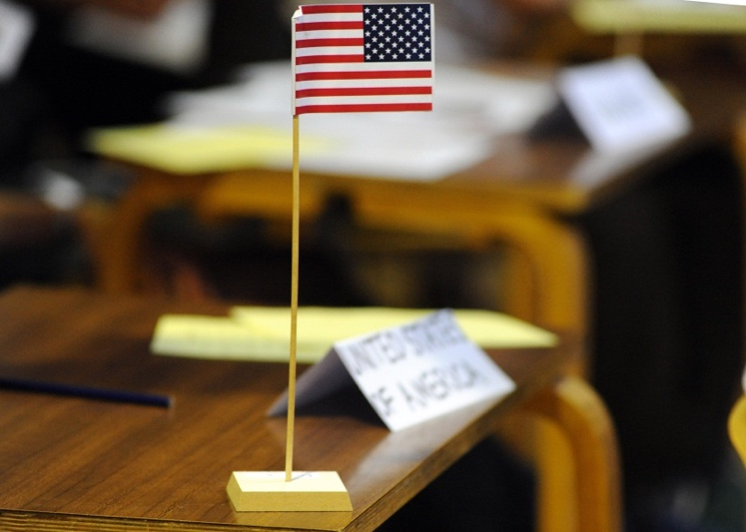

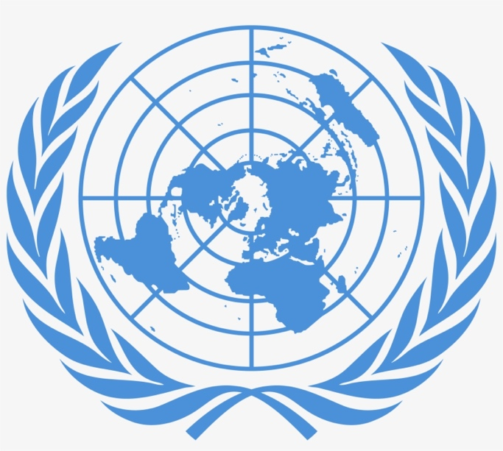

“All human beings are born free and equal in dignity and rights. They are endowed with reason and conscience and should act towards one another in a spirit of brotherhood.”

Article 1 Universal Declaration of Human Rights.

Contents Page

Page Number

- The United Nations and groups………………………….……………..4-5

- Preparing to be a delegation…………………………………………….6-7

- Country Fact file……………………………………………………….……….8-9

- Sustainability………………………………………………………….…………10

- Climate Change and your country……………………………………..11

- Writing your speech………………………………………………………….12

- The Resolution from the honourable delegation for Chile…13

- Attending Countries…………………………………………………………..14

- Timings of the day…………………………………………………………….15

- Writing your summary article……………………………………………16 - 17

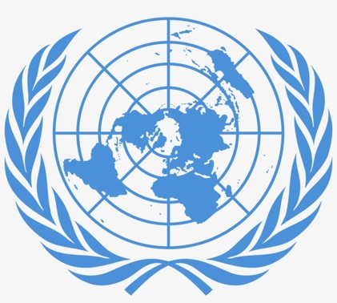
The United Nations

In 1945 the nations of the world laid down their weapons, bringing to an end one of the most brutal conflicts in history, the Second World War. Determined to try to avoid conflict in the future, the United Nations Charter was signed. Initially there were 50 member countries, now there are nearer 200.

The UN has its world headquarters in New York, USA. Here two of the main bodies of the UN meet – The General Assembly and the Security Council. The General Assembly is a meeting of all nations which happens rarely because it is too big to be a working body.

Important decisions are made in the Security Council. This has just 15 members, so it is a better size for discussion and debate. Each of the nations of the UN takes its turn to serve for two years on the Security Council, apart from 5 nations who are permanent members. These are China, France, Russia, UK and USA. Many people think that having any permanent members is unfair.

The UN also sends soldiers around the world to keep peace. UN peacekeeping troops are currently working in 15 locations throughout the world.
The UN is the closest thing we have to a world government but it has little power. It has not stopped war or suffering but it has helped to reduce it.

What else does the United Nations Do?
- Helps to look after and protect children
- Negotiates international travel routes, particularly air routes
- Provides assistance to countries once a conflict or war is over
- Fights world disease. Smallpox has disappeared as a result of the UN
- Helps refugees and displaced people who have been forced to flee from their homes
- Helps to improve the provision of education worldwide
- Encourages the protection of the environment
- Promotes family planning and monitors world population growth
- Works with Governments and scientists to increase the production of food
- Provides inspectors to help keep the peace in former conflict zones such as Afghanistan.

Some United Nations organisations & groups


UNESCO – United Nations Education, Social & Cultural Organisation


WFP – World Food Programme

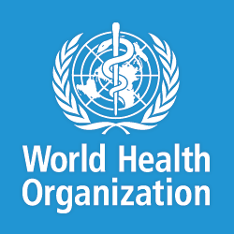
WHO – World Health Organisation

WCP – World Climate Programme

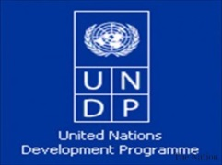

UNDP – United Nations Development Programme

UNPD – United Nations Population Division
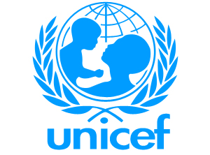

UNICEF – United Nations Children Fund

The United Nations main aims are to prevent conflict and to improve the quality of life for people.

How can you prepare to be a delegation?

- Find out about your allocated country: complete the fact file on the following pages in as much detail as you can using the world factbook on CIA.gov website.

- Find out about how climate change is affecting your allocated country:

  - What problems have been caused by climate change?
  - What do you think the causes of these problems are?
  - What, if anything, is your country already doing to tackle climate change?
  - What changes would you like to see to overcome these problems in the longer term?

- Prepare a speech on your response to the resolution :

- This should be detailed but should identify which parts will be read out so that it does not exceed 2 minutes.
- Prepare your own defence. You might be a country that will be attacked by others. Research your own position and try to anticipate what others might say about you.
- If any country mentions your country during the debate, you have the “right to reply”. This means you have the opportunity to answer your critics.
- What can you find out about other countries wrongdoings?
- You may wish to suggest a change to the wording in the “decides”. This is the part of the resolution you actually vote on. This is called an amendment. It should be written in advance of the meeting and can be passed to the Chair during your speech.
- Allocate specific tasks to each team member.

Research and preparation

- Complete your fact file using CIA world factbook: www.cia.gov
- Watch YouTube videos on your country and climate change: [Vox, RT, GeographyNow, SciShow, TEDTalks, NatGeo, Now this news, CNN, BBC, Al Jazeera English]
- Watch the news on TV or read in newspapers/websites.
- Listen to podcasts: [BBC’s costing the earth, climate one, climate cash, warm regards]
- Visit websites and search engines.
  - www.un.org
  - www.climateactiontracker.org
  - www.bbc.co.uk
  - www.channel4.com
  - www.guardian.co.uk/environment

  - https://www.theguardian.com/news/datablog/interactive/2013/jul/16/carbon-emissions-carbon-tax (or scan the QR code --->)

- School library e.g. most recent edition of the New Internationalist “World Guide” has details on every country.
- Geography department e.g. atlases, text books, geography library in G1

Country Fact file:__________________________________________________ (name of country)

Use the CIA world fact book for most of the statistics and figures. Use google, the BBC and other news websites to find out about climate change issues.
PHYSICAL GEOGRAPHY

Climate:

Highest elevation:

Coastline: Yes/No

Terrain / ecosystems:
Map of your Country:

HUMAN GEOGRAPHY

Total population:

Language:

% population urban:

Average population density:

% population working in agriculture (farming):

Total carbon emissions:

% of world carbon emissions:

Carbon emissions per capita (world rank):

Refugees/IDPs (causes due to CC?):

DEVELOPMENT INDICATORS

GDP per capita: $US

Life Expectancy:

Infant mortality rate:

Population below the poverty line:

HDI:

Median age:

Mothers mean age at first birth:

Birth rate:

Total fertility rate:

ENERGY

% electricity from fossil fuels:

% electricity from nuclear power:

% electricity from Hydroelectric Power:

% electricity from other renewables:

Carbon dioxide emissions from consumption of energy:

Electrification – total population:

POLITICAL GEOGRAPHY

Name of leader:

Bordering countries:

Are you an HIPC country (highly indebted poor country)?
YES/NO

Signed up to the Kyoto Protocol?
YES / NO

Type of state governance: [democratic, dictatorship, socialist etc.]

What did your country pledge in terms of its INDC (Intended Nationally Determined Contribution) at the Paris 2015 Summit– you can find this at: http://www.carbonbrief.org/blog/2015/03/paris-2015-tracking-country-climate-pledges/

Google Climate Action Tracker to see what is said about the effectiveness of your pledge:

Have you signed AND ratified your pledge yet? http://climateanalytics.org/hot-topics/ratification-tracker.html

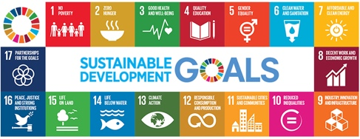

Sustainable development Goals:

What are the following U.N. SDG’s for 2030?

7.

9.

11.

13.

SUSTAINABILITY & CLIMATE CHANGE

Fair solutions that meet the needs of the poorest & most vulnerable people & countries.
Long-term solutions that meet the needs of people today without preventing people in the future from meeting their own needs.

Sustainable Management of Climate Change

Effective solutions which reduce greenhouse gas emissions.
Solutions that are cost-effective.

Solutions which protect habitats, ecosystems and buildings.
Solutions that use green technology and businesses to aid development of the economy.

TASK: Shade the boxes to show the social, economic & environmental aspects of sustainable management of climate change.
KEY: □ Social □ Economic □ Environmental

Issues to do with climate change in this country (e.g. causes, effects or things being done to tackle it) Continue your notes on separate paper if necessary.

How your MUN speech might look……
BE PASSIONATE, BE PERSUASIVE, BE PROVOCATIVE!

Writing your speech:
Your speech aims to be detailed enough to show a thorough understanding of your country’s position with regard to climate change. Therefore you should write as much as you feel necessary to do this and hand it in at the assessment stage. However, during the debate itself you will only be allowed 2 minutes to speak, so you should carefully highlight / make bullet points, or have a separate summary of the things you consider crucial.

It will probably begin something like this: [*blue = these bits should form the main part of your speech]

- “Madam Chair, Honourable delegates,

- “We are here today representing the proud (or other adjective to describe your country!!) nation of”…
(Here you could describe relevant facts about your country that will introduce you to the other delegates – its population, politics, history, wealth (GDP?), main industries etc. BUT KEEP THIS BRIEF).

- “With regard to climate change”*…
What are the specific concerns for your country now and in the future? Are you a major contributor to greenhouse gas emissions (figures for your nation and/or per person may tell very different stories!?). What did you promise for your INDC’s (Intended Nationally Determined Contributions)? Have you signed and ratified this yet? Are you taking any actions to moderate your emissions and meet the INDC e.g. using renewable forms of energy etc. Are you angry with any particular nations that you may wish to cite (mention in an accusing way – remember if you cite anyone they have a ‘right to reply’, so be ready to argue your point)? Do you sympathise with any nations in particular? Is anyone likely to cite you – do you have a defence for your actions??

- “With regard to the DECIDES”*……
Talk about each decide in turn discussing whether it affects you, whether you consider it realistic, achievable, fair, practical, not enough or too much. Try to persuade or discourage others.

Finally, will you be supporting the resolution (which means agreeing with all 3 decides as they are). Would you agree if one or more of the Decides were amended in some way? (Write any such amendment down and hand it in after your speech).

Year 9 Model United Nations
Resolution by the Honourable Delegation for UK

CONCERNING the actions and non-actions by UN member states in relation to the increasing threat of global warming.

REMINDING delegates of the words of the IPCC 5th assessment that ‘the warming of climate and ocean systems since 1850 is unequivocal with a 95% probability that human action is the dominant cause of this warming’.

FURTHER REMINDING colleagues of the words of, the secretary General of the UN that ‘despite the fact that all countries will face adverse effects of continued warming, it is the poor nations that will suffer most. Climate change is undoubtedly the defining issue of our era’.

FEARFUL that failure to take immediate action could result in exceeding a 2°C ‘tipping point’, beyond which the Earth’s natural systems will not recover. This will result in sea-level rise, the melting of ice caps and glaciers, declines in the world’s ability to produce food and the catastrophic loss of animal and plant species.

CITING all countries who have yet to sign and ratify the pledges made in Paris, notably the wealthy nations of Australia (who also failed to ratify at Kyoto), Germany, France, Russia, UK and Saudi Arabia.

ALARMED that other wealthy developed nations, such as Canada, the USA, and Japan, along with the rapidly developing nations of China, India, Mexico and Brazil, continue to put their own nation’s short term interests before the longer term interests of planet Earth and its poorest nations.

CALLING FOR the urgent signing of a legally binding treaty which agrees to the following.

The Resolution:

DECIDES 1: All nations to have net carbon-free economies by the year 2030.

DECIDES 2: All of the world’s largest carbon emitters to increase their INDC’s (Intended Nationally Determined Contributions) by 20% and ratify this with immediate effect.

DECIDES 3: The top 20 wealthiest nations to contribute $5billion dollars per year on an indefinite basis to the ‘Green Climate Fund’ (GCF) to help the poorest countries cope with the impacts of climate change.

Country delegations attending the conference

Teacher 1 | Teacher 2 | Teacher 3
CHINA | BRAZIL | USA
UK | KIRIBATI | FRANCE
INDONESIA | GERMANY | MALDIVES
JAPAN | AUSTRALIA | ICELAND
ETHIOPIA | NICARAGUA | SAUDI ARABIA
BANGLADESH | RUSSIA | INDIA
CANADA | CHAD | CHILE
COSTA RICA |  | SOUTH AFRICA
 |  | NIGERIA

Timetable of proceedings: XXXDATEXXX

Time | Activity
9.15 - 9.20 | Delegates arrive and prepare
9.15 – 9.25 | Delegates at their tables  Introduction & welcome  Run through procedures  Reading Article 1 Universal Declaration of Human Rights
9.25 | The RESOLUTION  Presented by the hosts of the conference, the delegation from UK, concerning the need to put promises made in Paris in 2015 into action.  Speeches, amendments by each country
11.00 | Break
11.30 | Resume speeches and amendments
12.30 – 12.40 | Vote on the resolution
12.40 – 12.50 | Plenary discussion
12.50 | Clearing up
1.10pm | Lunch
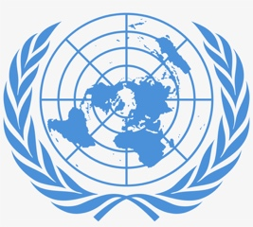
Briefing Notes: Year 9 Model United Nations Conference Assessed Work

You will have plenty of opportunity during the preparation for the conference, on the day itself and during the follow up work to show your understanding of the issues surrounding sustainable management of climate change. You will be assessed in a variety of ways to give you every opportunity to show your best work.

- During the preparation work:

You will be assessed on your overall engagement, your focus and your level of geographical enquiry (for example asking investigative questions). You will be assessed by your teacher and will assess yourself. (See the feedback sheet so you know what to aim for).

- On the day:

You will deliver your speech, respond to the questions of others and challenge other delegations. This will be another opportunity to show both your understanding and engagement. Your teacher will give you written comments afterwards about what you did well and any thoughts for further improvement in the future.

- Follow up work:

You will write an article as a journalist for a serious newspaper reporting on what was discussed at the conference. Use the guidelines and the assessment criteria sheet to ensure you include geographical information and show your knowledge of the countries involved in the conference and your understanding of global climate change and sustainability issues.

TO BE HANDED IN AFTER FEBRUARY HALF TERM

Briefing for Journalists covering the MUN on Climate Change 2020

Write an article summarising the events and issues covered at the 2020 Model United Nations Conference on Climate Change

Intro: Set the scene: What is climate change? Why does it need to be tackled?
[Aim for min. 250 words]

Main body of the article:
What are the views of some example countries? What are your opinions about the views presented; were they sustainable? Who causes climate change? Who is suffering? What are countries already doing to tackle climate change? What was decided?
[Aim for: 500-600 words]

Conclusion: Were you satisfied with the outcome of the conference? What do you think should be done to tackle climate change (consider describing what countries are already doing)?
[Aim for: 200 words]
You will be assessed on your knowledge & understanding of:
- The countries involved and how they affect each other.
- How climate change can be managed sustainably.

How to structure the main body of my article: remember to PEEL in every paragraph and to use facts, figures and real examples.

P (oint): Make a clear point at the start of the paragraph e.g. Bangladesh argued that they suffer more from climate change than rich countries do.

E (vidence): Back it up with a fact e.g. Most of Bangladesh is at or near sea level and it has experienced an increase in tropical storms and cyclones due to global warming.

E (xplain): Develop your point e.g. Bangladesh has not got the money to deal with the effects of these storms and releases far less Carbon Dioxide than countries like the USA, so were not responsible for causing the problem.

L (ink): Link this paragraph to your next point e.g. At the conference Bangladesh wanted developing nations to be allowed to increase their carbon emissions but the USA did not agree…

