Development Indicators | Data for your country
Median Age | 39.8 years
Mothers mean age at first birth | 24.6 years
Infant mortality | 6.7 deaths / 1000 live births
Fertility rate | 1.61 children born / woman
Life expectancy | 71.3 years
Birth rate | 10.7 births / 1000 population
Death rate | 13.4 deaths / 1000 population
Adult literacy | 99.7%
Obesity prevalence | 23.1%
Urban population | 75.4%
Number of airports with paved runways | 594
Population without electricity | 0%
Electricity from fossil fuels | 68% (nuclear 11%, hydro 21%)
Electricity from other renewable sources | 1%
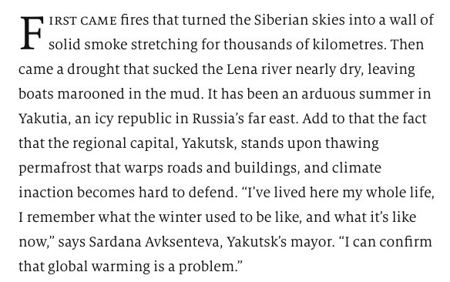
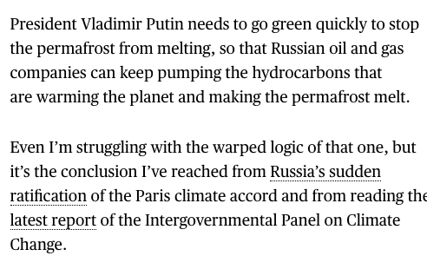







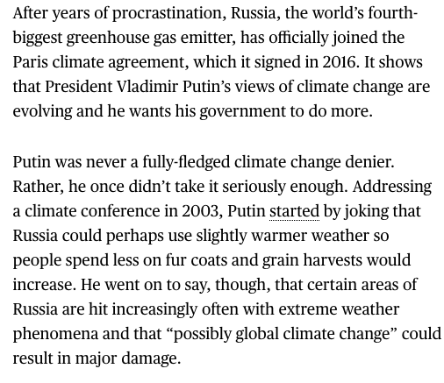

Factor | Your guess
LIDC/EDC/AC
Continent
View on Climate Change
Country 1st guess
Country 2nd guess

