- Systems in physical geography, systems concepts and their application to the development of coastal landscapes inputs, outputs
- Energy stores/components
- Flows/transfers
- Positive/ negative feedback
- Dynamic equilibrium

3.1.3.1 Coasts as natural systems

- The concepts of landform and landscape and how related landforms combine to form characteristic landscapes.

- Sediment sources, cells and budgets.

- Sources of energy in coastal environments: winds, waves (constructive and destructive), currents and tides. Low energy and high energy coasts.

3.1.3.2 Systems and processes

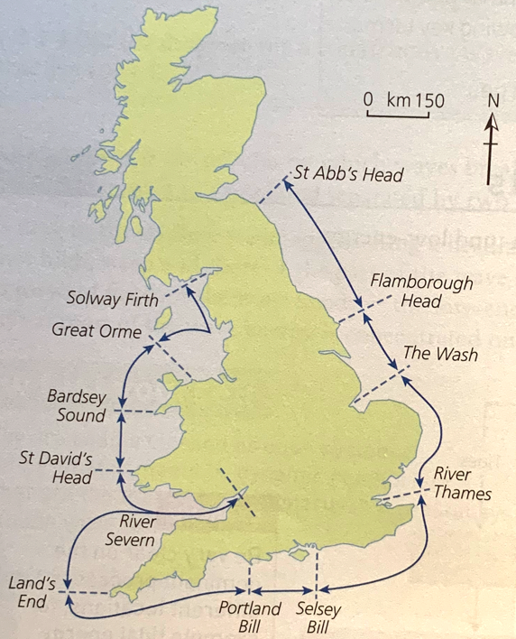

- Distinctively coastal processes: marine:
  - erosion – hydraulic action, wave quarrying, corrasion/ abrasion, cavitation, solution, attrition; transportation: traction, suspension (longshore/littoral drift) and deposition; sub-aerial
  - weathering, mass movement and runoff.
- Geomorphological processes: weathering, mass movement, erosion, transportation and deposition.

3.1.3.2 Systems and processes

- Origin and development of landforms and landscapes of coastal erosion: cliffs and wave cut platforms, cliff profile features including caves, arches and stacks; factors and processes in their development. (UK and abroad examples needed).

3.1.3.3 Coastal landscape development

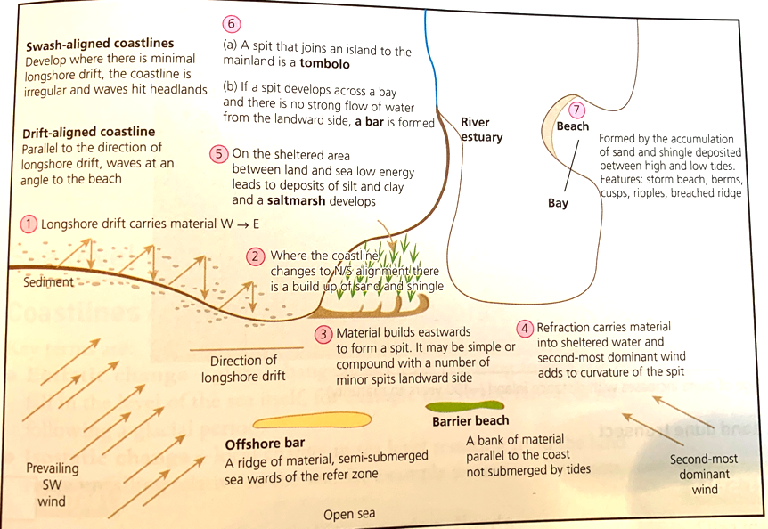
- Origin and development of landforms and landscapes of coastal deposition. Beaches, simple and compound spits, tombolos, offshore bars, barrier beaches and islands and sand dunes; factors and processes in their development. (UK and abroad examples needed).
3.1.3.3 Coastal landscape development

- Eustatic, isostatic and tectonic sea level change: major changes in sea level in the last 10,000 years.

- Estuarine mudflat/saltmarsh environments and associated landscapes; factors and processes in their development.

3.1.3.3 Coastal landscape development

- Recent and predicted climatic change and potential impact on coasts.

- Coastlines of emergence and submergence. Origin and development of associated landforms: raised beaches, marine platforms; rias, fjords, Dalmatian coasts.

3.1.3.3 Coastal landscape development

- The relationship between process, time, landforms and landscapes in coastal settings.
- Sustainable approaches to coastal flood risk and coastal erosion management: shoreline management/integrated coastal zone management.

- Human intervention in coastal landscapes. Traditional approaches to coastal flood and erosion risk: hard and soft engineering.

3.1.3.4 Coastal management

- Students must engage with a range of quantitative and relevant qualitative skills, within the theme landscape systems. These should include observation skills, measurement and geospatial mapping skills and data manipulation and statistical skills applied to field measurements.

3.1.3.5 Quantitative and qualitative skills

- Case study(ies) of coastal environment(s) at a local scale to illustrate and analyse fundamental coastal processes, their landscape outcomes as set out above and engage with field data and challenges represented in their sustainable management.

3.1.3.6 Case Studies

- Case study of a contrasting coastal landscape beyond the UK to illustrate and analyse how it presents risks and opportunities for human occupation and development and evaluate human responses of resilience, mitigation and adaptation.
3.1.3.6 Case Studies

