The Kurdish Nation 1.a. The world political map of sovereign nation-states is dynamic
- The Kurds are a non Arab, Middle Eastern population.
- Inhabit area known as Kurdistan.
- Includes parts of: eastern Turkey, northeast Iraq, northwest Iran and small areas of Armenia and northeast Syria.
- Traditionally a nation of nomadic herders.
- Now mostly semi-nomadic or sedentary.
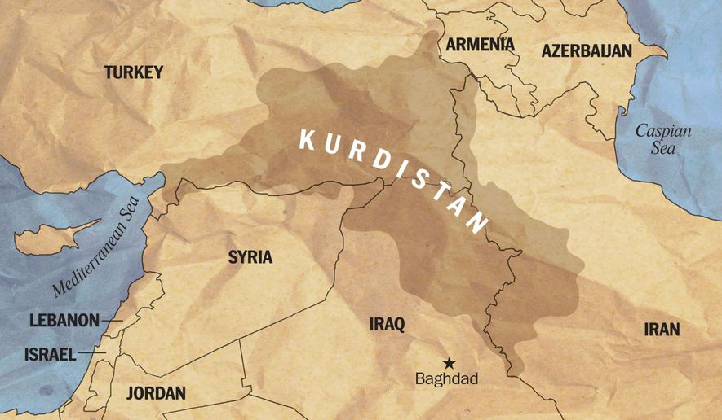

South China Sea: 1.a. The world political map of sovereign nation-states is dynamic
External Sovereignty = a state cannot simply proclaim sovereignty, there has to be a mutual recognition among other sovereign states. This ensures its territorial integrity and enables it to enter into international relations with other states.
Sovereignty authority includes:
- Rocks, soils, minerals, space beneath the surface
- Agreed areas of sea and sea-bed resources
- Agreed air space

The Basque Nation: 2.a. A multitude of factors pose challenges to sovereignty and territorial integrity
- Located in northeast Spain and southwest France.
- ETA are a Basque separatist and terrorist group
- The Basque nation is one of the oldest ethnic groups and languages (Euskara).
- Challenges to territorial integrity and sovereignty have arisen in Spain and France where the Basque Nation has long struggled for independence.
- The Basque country crosses 4 provinces of Spain and 3 in France.
- The population is 3.1million.
- Euskara the Basque language is taught in schools.
- Traditional cultural features include: architecture, food and dance in the area.
- They have their own Basque parliament and political autonomy.
- ETA have been violent because they have been oppressed by the French and Spanish governments in the past. They are suppressing their identity because it is seen as a threat to their sovereign power and potentially their territorial integrity.
- Recently issues have been the dispersal of political prisoners among French and Spanish prisons. Including, members of ETA, pro-independence politicians, members of Basque youth movement and journalists.
- There was an ETA ceasefire in 2011 and since then the separatists have undertaken peaceful protests. For example a human chain from Durando to Pamplona in 2014 and marches in the streets of Bilbao about the lack of human rights to political prisoners.

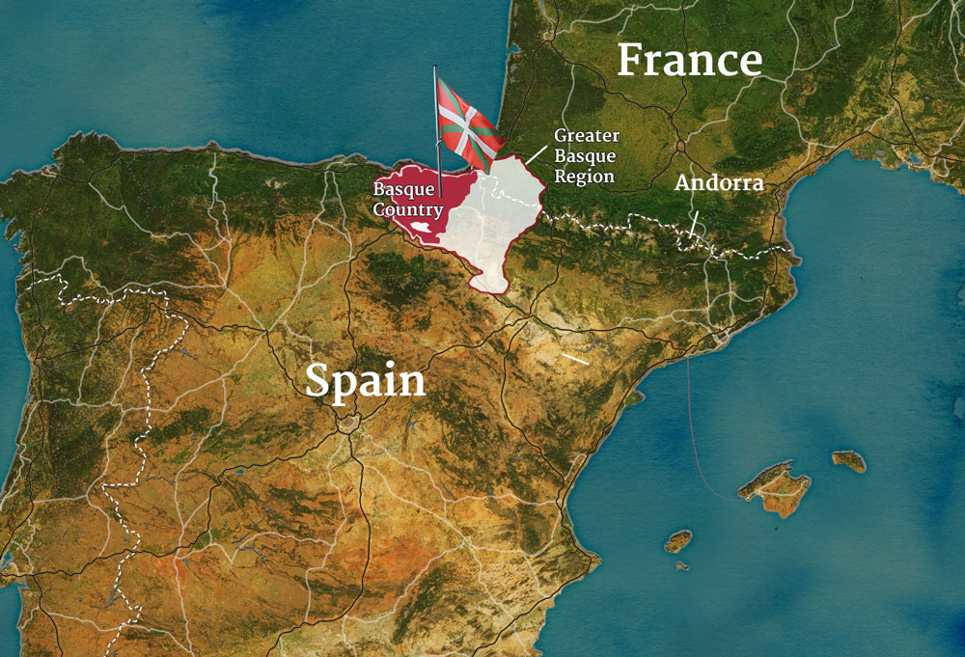

Kashmir: Global governance provides a framework to regulate the challenge of conflict
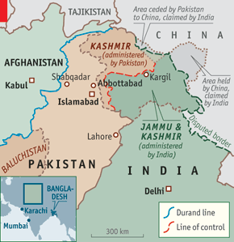
Natural resources: water supply conflict: Kashmir
- Sovereignty over Kashmir has been contested between Pakistan and India since the partition of India in 1947.
- Firing across the border by both countries has caused many deaths and a lot of IDPs of thousands of poor farmers and their families.
- Troops are even stationed at 6000m (Rainbow mountain is 3500m, Everest is 8848m i.e. it will be cold and horrible altitude sickness so they are risking a lot up that high) altitude to control the territory of Siachen Glacier which is a major source of the River Indus.
- Water insecurity is at the heart of the conflict because of irrigation and hydro electric power (HEP).
- The World Bank mediated the Indus Water Treaty in 1960.
- However, Pakistan is downstream and insists India adversely affects the water supplies by damming the upper tributaries which flow through Kashmir.
- The dispute also has cultural and ethnic and religious reasons.
- The dispute is of increasing importance because:
  - Both populations are increasing and therefore their water demands are growing too.
  - The water resource itself is depleting due to global warming causing the Himalayan glaciers to retreat.
The dispute remains unresolved, requiring greater co-operation between the two countries.

