- a. The world political map of sovereign nation-states is dynamic. Page 263 - 269
8 examples of new groups of countries since 1990:

What is a state? (Acronym help: RT PP SS/ right poo poos)

Changes to the world political map:

What is a nation? Example = Kurds:
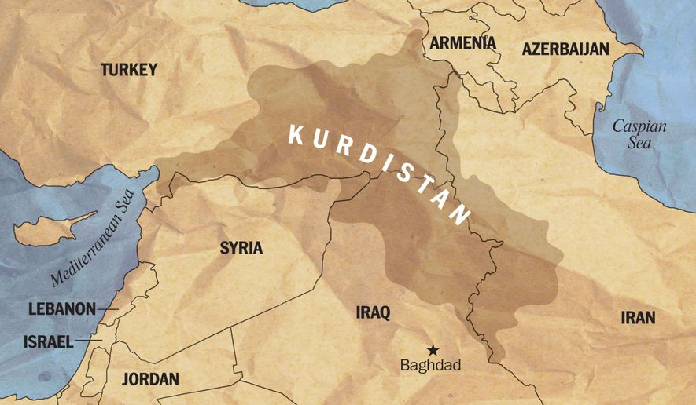

Territorial integrity:

Sovereignty:

Geopolitics

Norms

Intervention: (Acronym help = HMM E, which is the sound we make relating to how we feel about intervention aka its complex)

