- a. A multitude of factors pose challenges to sovereignty and territorial integrity. Page 270 - 274
Research TNC:
Research 1 of MS TECC:
How TNCs challenge state sovereignty:
6 ways control of territory has been contested and destabilised, (Acronym help = MS TECC like it is a mistake to challenge sovereignty)
Current political boundaries:
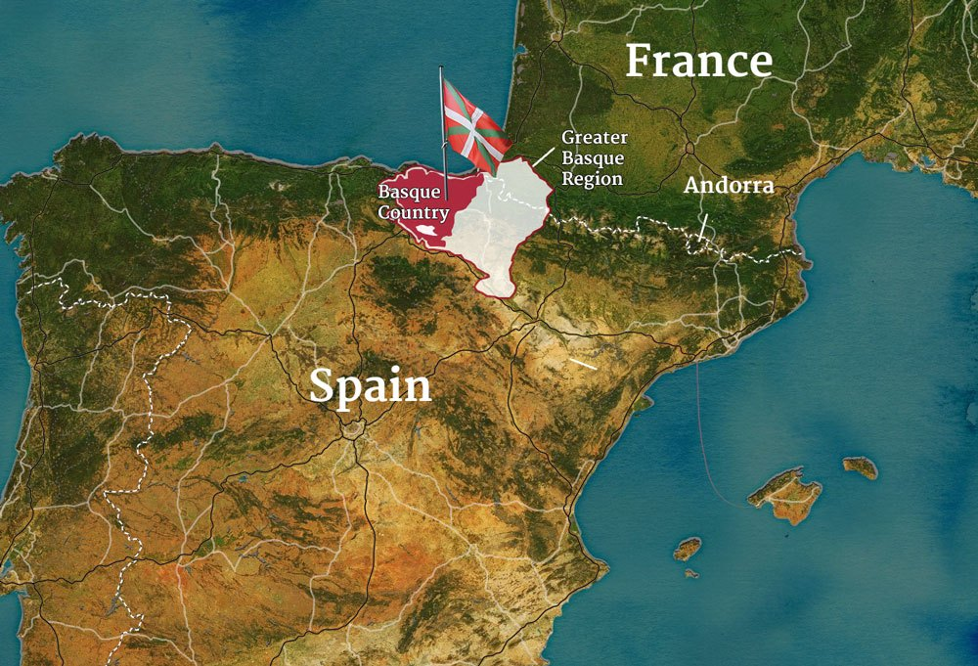
Supranational institutions e.g. trade blocs:
European Union:
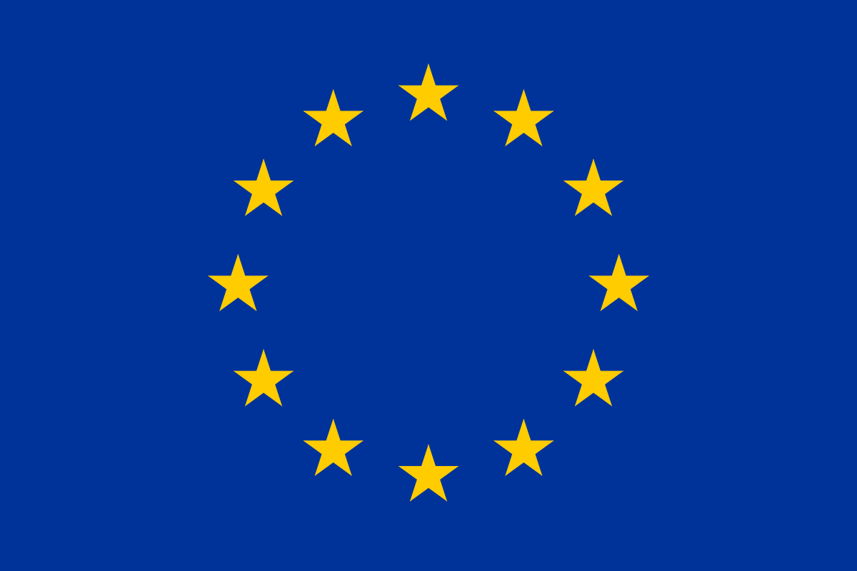
United Nations:
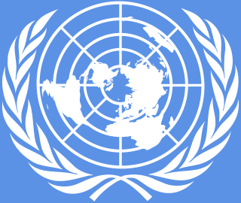
Political dominance of ethnic groups: Example = Basque Nation, Spain.
