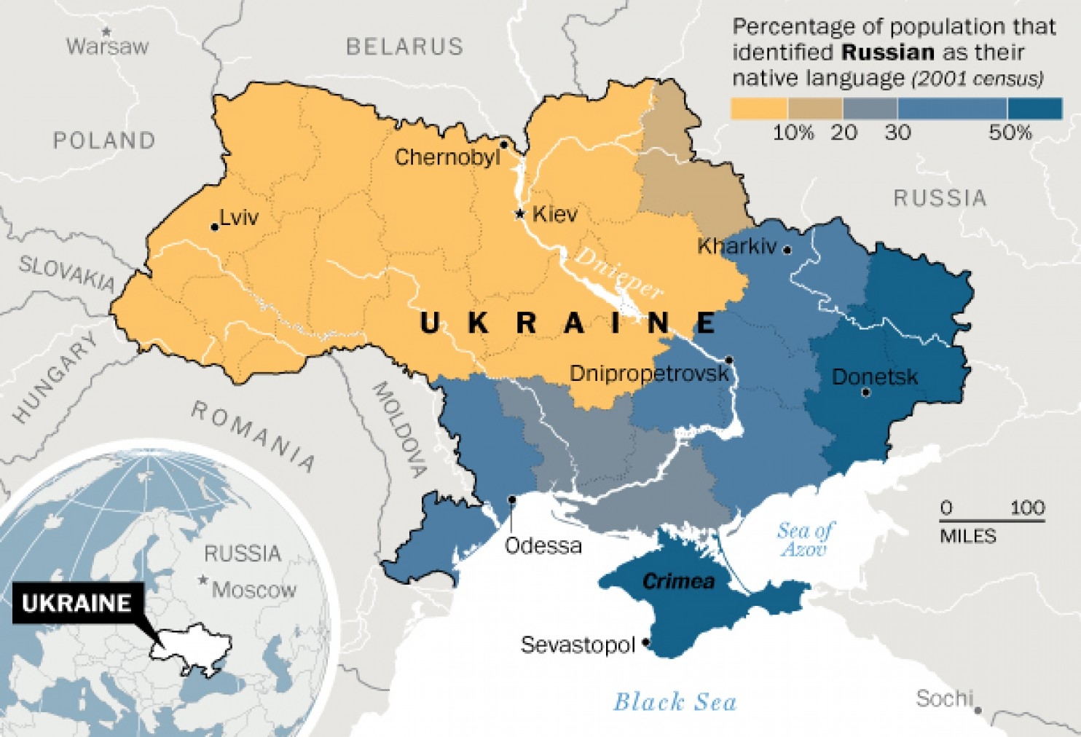
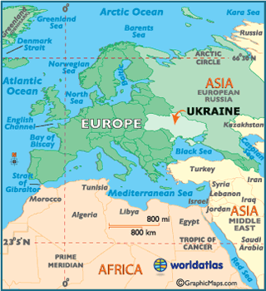
- a. A multitude of factors pose challenges to sovereignty and territorial integrity. Case Study: Ukraine Page 275 - 276
Causes and challenges to the government:
Country geo-political context/history:
Locate Ukraine:
Why does Russia want control of Crimea? (web links on canvas)
The international response: (Google)
Time line: (Google/BBC News links on canvas)
Impacts of conflict on places:
Impacts of conflict on people:

