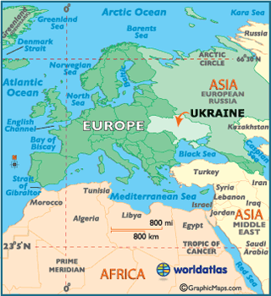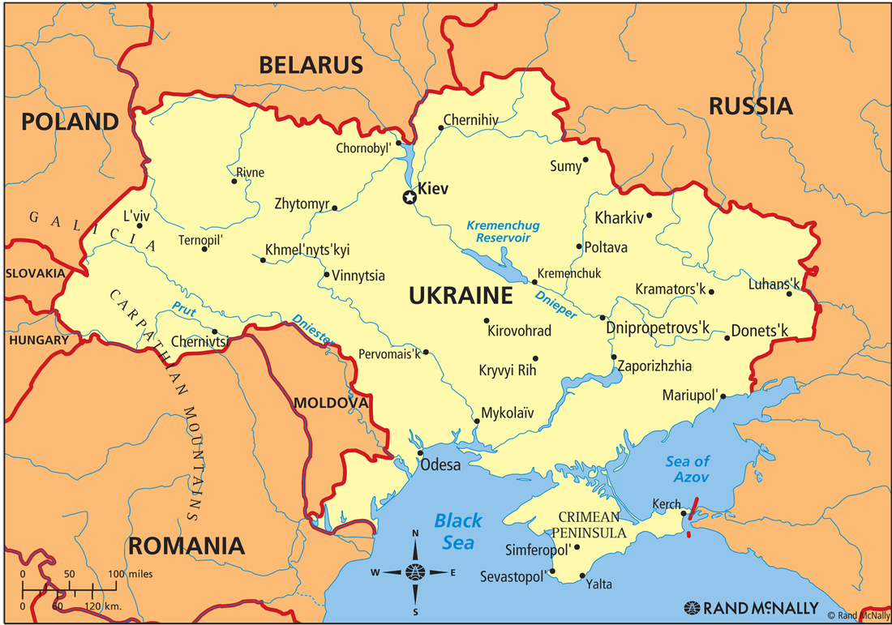

Locate Ukraine: Use the maps above to answer the below questions:

a. Name the 7 countries which border the Ukraine.

b. What continent is the Ukraine in?

c. What sea’s does the Ukraine border?

d. What is the capital of Ukraine?

e. What is the biggest political power which borders the Ukraine?

f. Chernobyl is a town in the Ukraine, do you know anything which happened here?

Notes:

Quick fire data on Ukraine:

 | Number | Fact
1 |  | Number of people who speak Russian
2 |  | Population
3 |  | Number of bordering countries
4 |  | Number of people between 25-54 years old
5 |  | Population growth rate
6 |  | Highest point
7 |  | People living with HIV/AIDS
8 |  | Life expectancy
9 |  | Mothers mean age at first birth
10 |  | kW of energy produced
Numbers:
- 7
- 2061m
- 44,000,000
- 17.3%
- 24.9
- 44.29%
- 152.2 billion
- -0.41%
- 72.1
- 240,000

…………………………………………….…………………………………………….…………………………………………….

Factor | West Ukraine | East Ukraine
Language
Ethnicity
Political
Economic

Main challenges to Ukraine forming a stable government

1
2
3
4

Reforms to state apparatus needed include:

1
2
3
4
5
6
7

8

9

