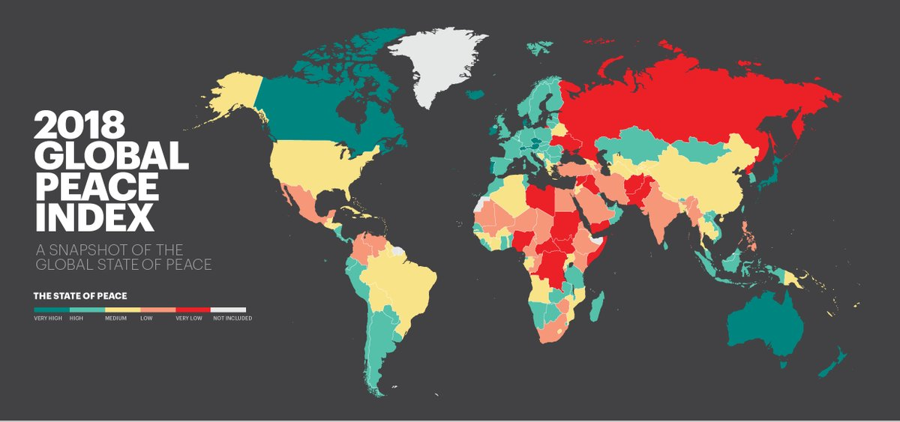
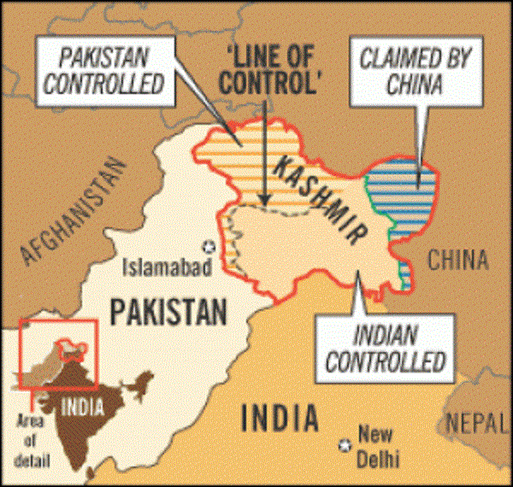
3. a. Global governance provides a framework to regulate the challenge of conflict. Page 277 - 281
Natural resources: water supply conflict, Kashmir:
Global Peace Index: www.visionofhumanity.org
How challenges to sovereignty and territorial integrity can be a cause of conflict: Acronym: MR V. FILE

Treaties, laws and norms
Non-governmental organisations:
The United Nations: Acronym: UK/TMS/CHD/JP:

North Atlantic Treaty Organisation (NATO):
The role of flows of people, money, ideas and technology in geopolitical intervention:
The European Union:
The role of institutions, treaties, laws and norms which are significant in regulating conflict and reproducing the global system of sovereign nation-states.

