4.a. Global governance of sovereignty and territorial integrity has consequences for citizens and places.
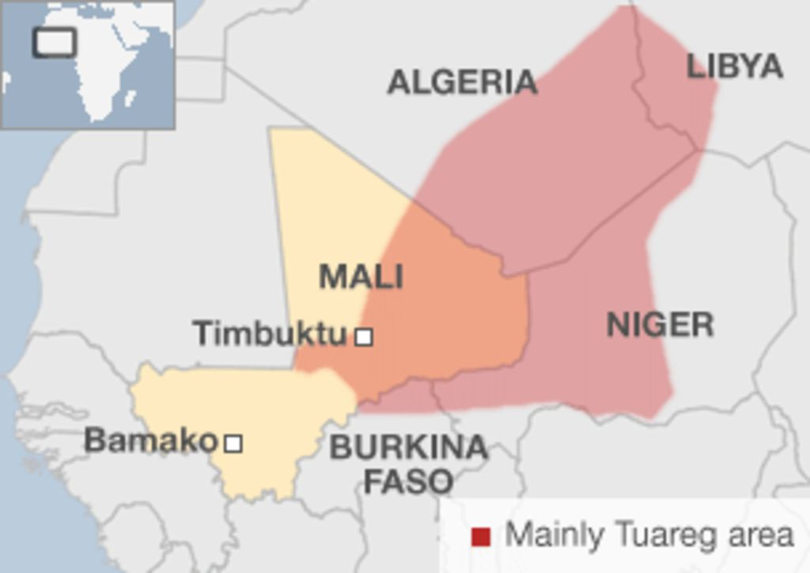
Case Study: Mali Page 285 - 287
Global governance strategies:

Geo-political and historic context:

Sovereignty and territorial integrity issues:

Locate Mali:

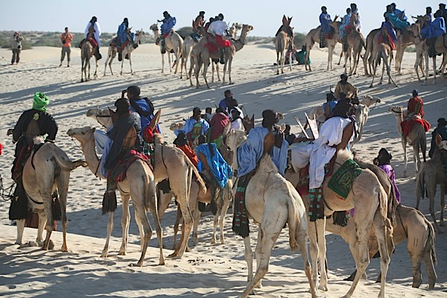

Opportunities: Development:

Challenges: Injustice

Opportunities: Growth:

Opportunities: Stability:

Challenges: Inequality

