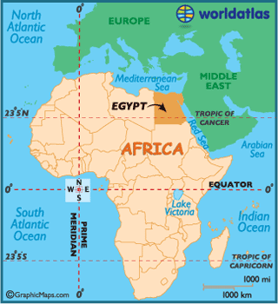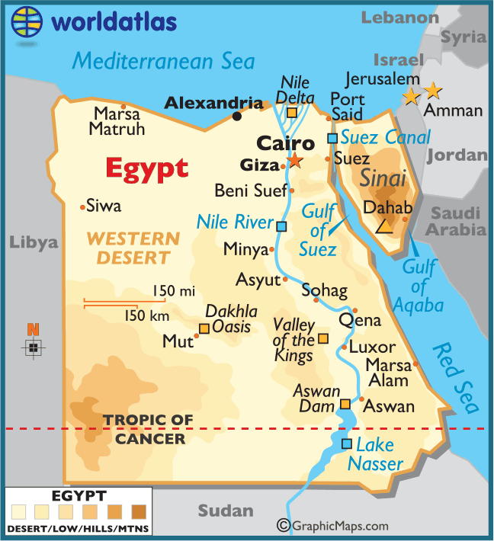
Map 1 Map 2

Nile Delta:

- Using Map 1 describe the location of Egypt (use the compass rose and lines of latitude and longitude)

- Using Map 2 describe the location of the Nile Delta.

- Describe the land of Egypt using the key on map 2.

- Name some of the main landmarks in Egypt using map 2.

- Using both maps and possibly an atlas for clarity name the countries which Egypt borders.

- Write down all the things you already know about the Nile, what is it known for, what things/words/smells/sounds/feelings/ideas/music do you associate with it?

