Power and Borders: South Sudan, Africa: 3.b. Global governance involved cooperation between organisations at scales from global to local, often in partnership
The situation:
- This case study shows strategies for global governance in an area of conflict. It demonstrates interventions and interactions of organisations at a range of scales, including the UN, NGOs and national governments, and consequences of global governance for the conflict for local communities.
- South Sudan is the world’s newest sovereign state as it gained independence from Sudan in 2011. It is a land locked country with a youthful population.
- Since independence it has experienced poor governance and difficulty nation building.
- In 2013 the political infighting between President Kiir (of Dinka ethnicity) and Vice-President Machar (of Nuer ethnicity) turned into serious armed conflict with an ethic component.
- This has led to thousands of deaths, 1.5 million IDPs and 730,000 refugees in neighbouring countries.
- A further 8 million are at risk of food insecurity, with 1 in 3 children suffering malnutrition.
- It’s power and sovereignty have been weakened by government failure to meet its responsibility to protect its citizens.
- Intervention and interaction of organisations can happen at a range of scales (global, national, local) including the UN, national government and NGOs. However, all has to co-operate together.
- Intervention by the international community has been necessary to resolve the conflict and ease suffering.
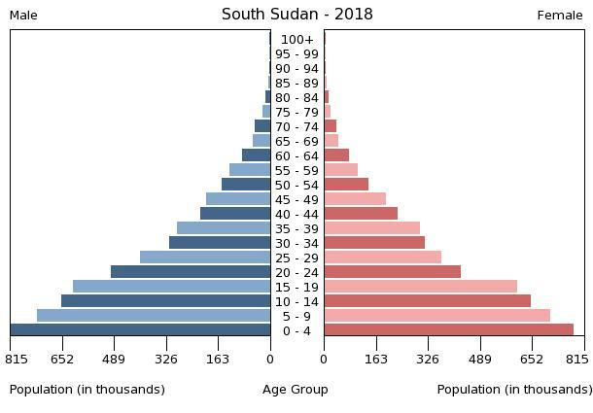

NGOs:
- Many NGOs work with the UN assisting local communities. South Sudan NGO Forum organises more than 300 NGOs addressing humanitarian and development needs.
- However, there has been harassment and violence against NGO workers, including their forced evacuation of the Upper Nile state, leaving populations vulnerable and blocking use of the Nile for the delivery of food relief.
- NGOs working in South Sudan: Medecines Sans Frontieres (MSF), Amref, Save the Children, Oxfam, Terre des Hommes, Care.

The UN:
- The UN peacekeeping Mission (UNMISS) was reinforced in 2014 with a new mandate.
- Originally after 4 years of independence, the mandate was to support the South Sudanese government in peace consolidation, state-building and economic development.
- However, following the December 2013 crisis, military and police presence has been increased.
- This involves 12,500 military personnel, 1000 police plus 25000 others contributing from countries across the globe. (Flows of people and money are important to governance and conflict resolution).
- The new emphasis has been to consolidate peace and security, protect civilians, monitor human rights, implement the Cessation of Hostilities Agreement and support delivery of humanitarian assistance.
- Other UN agencies working in the country include: UNICEF (United Nations International Children's Emergency Fund). UNICEF is an important in South Sudan as total fertility rate is 5.3 and 45% of the population is under 15 years old.
- The WHO (World Health Organisation) is operating in an oral cholera vaccination campaign.
- OCHA (UN Office for the Coordination of Humanitarian Affairs), concerned with hygiene and provision of safe drinking water.
- UNHCR (UN High Commissioner for Refugees) has urged the government to sign international conventions for refugee protection and it coordinates partnerships between UN agencies in South Sudan government agencies to assist displaced people especially unaccompanied separated children.

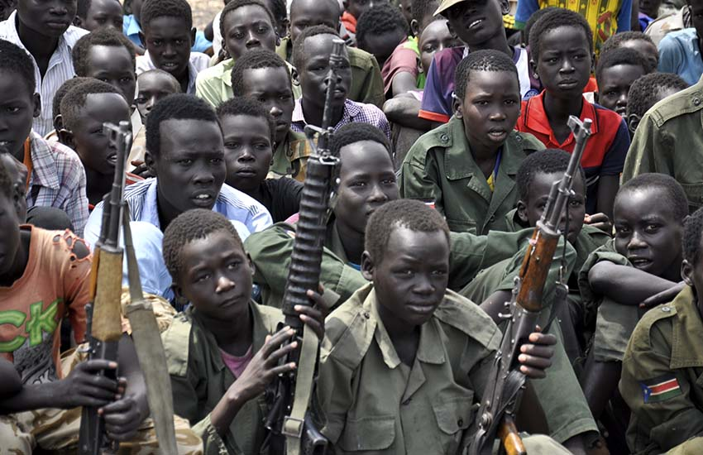
The South Sudanese government:
- The UN Security Council is highly critical of the South Sudan government for failing to protect its citizens.
- It has called upon the government to put the good of the country and its peoples before the personal ambitions of the leaders, and to find a political rather than military solution to the conflict.
- UNHCR has attempted to engage in government agencies as partners, including the Commissioner for Refugee Affairs, the Directorate of Nationality, and the South Sudan AIDS Commission.
- However human rights violations in the Unity and Upper Nile Provinces have continued including attacks on the UN peacekeepers, humanitarian personnel and on IDPs under UN protection at their sites near Juba where 20,000 people are sheltered.
- IGAD (Intergovernmental Authority on Development) is attempting to include the South Sudan government in mediation, but the government has prevented representatives from travelling to Addis Ababa (capital of Ethiopia) in order to participate in the IGAD Plus Peace Process.
- South Sudan has signed the following treaties:
  - Convention against Torture
  - African Charter on Human Peoples’ Rights
  - Convention on the Elimination of all Forms of Discrimination Against Women
  - Convention on the Rights of the Child
- Ratification of these treaties and a peace agreement signed in August 2015 have brought hope, but there are major obstacles to be overcome.
- Lack of government co-operation leaves long—term challenges such as alleviating poverty, improving the business environment, negotiating water and grazing (cattle) rights on the Central African Republic border and the trafficking of women and children.

Intervention in South Sudan has benefits at the local scale:
- Positive effects of global governance for local communities in South Sudan include:
  - Aid agencies have co-ordinated their efforts to position essential supplies during the dry season, enabling easier access to emergency food during the wet season when roads are difficult.
  - Villagers have received training in maintaining livestock health and use of fishing equipment to improve longer-term food security.
  - Vulnerable children have received treatment for acute malnutrition, for example via the work of MSF.
  - Aid agencies have negotiated access in areas where fighting is ongoing.
  - Civilian protection camps have been expanded for IDPs, providing shelter and food during the rainy season and protection from the fighting, which tends to escalate in the drier season.
  - WHO and its health partners have set up cholera treatment centres and provide advice on hygiene and access to clean drinking water.
  - Co-ordinated efforts have secured funds from various European governments
  - Many inhabitants of Upper Nile and Unity states have suffered because transport routes have been blocked and aid organisations on which they depend have been extorted (obtained by threats or force) for their resources such as supplies of food and medicine.
  - They are faced with problems such as having to abandon their homes, starvation and illness and children being forced into military training camps.
